

Spring 2019

ColoMATYC

Integrating by the Method of Indivisibles

Shawna L. Mahan

Professor of Mathematics

Pikes Peak Community College

Shawna.mahan@ppcc.edu

Integrating by the Method of Indivisibles

Shawna L. Mahan

February 2019

# A. Introduction

In pursuit of methods of calculating areas and arc lengths, John Wallis (1616-1703) extended the ideas and methods from Descarte’s *Géometrie* and Toricelli’s *Opera Geometrica* (1644), works about algebra and calculus, respectively. Toricelli’s work is inspired by Cavalieri’s theory of indivisibles, laid out in his *Geometrica* (1635), which was thought to have resurrected ancient Greek methods. His journey is laid out in his masterpiece, the *Arithmetica Infinitorum* (1655).

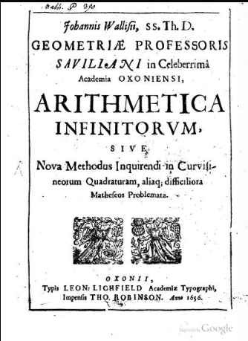

Title Page of *Arithmetica* *Infinitorum*, 1656 (first edition written in 1655), from digital scan by Google docs, 2018

During this period, Wallis has not worked in isolation. He was appointed the second Savilian chair of geometry in 1649 and was familiar with the works of other prominent mathematicians of the day as they are aware of his work. His peers are Fermat, Newton, Descartes, Cavalieri, Leibniz, Harriot, Gregory, Neil, Huygens, Pascal, Torricelli, and Oughtred, to name a few of them. His knowledge of mathematics was world encompassing. For example, he translated Archimedes’ *Sand-reckoning* (MacTutor History of Mathematics, Biography of Wallis). During this time, there are many arguments and feuds about provenance of ideas, many claiming to be premiere. One possible reason for this is the explosion of ideas related to number theory, calculus, algebra, and analysis which pour out of the mathematical community furiously. Newton gave credit to Wallis’s work in *Arithmetica,* for example, for his full realization of the binomial expansion theorem.

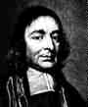

Portrait of Wallis taken from MacTutor History of Mathematics site

The structure of the *Arithmetica* is propositional and its objective is to turn a geometric figure’s area into chords, and in turn, turn the chords into an arithmetic progression. Wallis does this by inscribing areas in a variety of curves [Stedall, page 3]. Wallis wanted us to see the development of each of his ideas and often built from simple to complex, fairly quick. In this text, I see many familiar algebra notations, analysis, reasoning, and calculus concepts in their early or middle phases. Some of these are

* Pre formal definition of the limit (epsilon-delta thinking, similar to Archimedes);
* Figurate number representation, pattern use and extensions (triangle, square, pyramidal numbers);
* Inductive reasoning (he calls it induction) and interpolations;
* Rectifying curves, that is, finding the length of a curve, with particular interest in  and  forms;

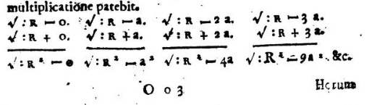

*Arithmetica* *Infinitorum*, Middle of Proposition 122, page 93

* The main focus of the text was the quadrature of the circle, that is, squaring the circle, evaluation of  by Cavalieri’s method of indivisibles;[1]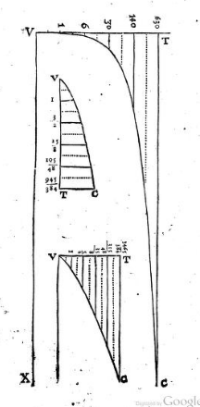

*Arithmetica* *Infinitorum*, Page ii, Circuli Quadraturam, the theory of indivisibles

* He created algebraic forms that helps other mathematicians further extend his initial or not fully formed ideas, such as his work with parabolas;
* New numbers in the number line: , ;
* Turned addition into multiplication to speed up convergence;
* Arithmetic-geometric means (I am only at the beginnings of truly understanding what he is doing here);
* Wrote algebraic FORMULAS for finite sums of integers, squares, cubes, and so on in proposition 2, 19, 20, and 38. We take these sums for granted and it is not given who first wrote these out. Wallis takes the new algebraic forms and begins to create formulas;
* Considered negative and fractional powers in proposition 87 and 53, respectively;
* Considered negative numbers under the square root without qualms.

In this text, Wallis continued to promote his symbol for infinity, ∞, created because it can be traced an infinite number of times. He used the symbol 🞎 to represent the proportion of a square’s area to its inscribed circle,  [Stedall, page 5]. The symbol for pi, π attributed to Euler, has not yet been standardized.

# B. The Method of Indivisibles – Sequences of Expanding Series

## Find The Area of a Triangle in Proportion to a Parallelogram

In the beginning of the text, Wallis connects sums to area, a familiar idea for mathematicians, in order to determine the area of a triangle in proportion to a parallelogram.

In Proposition 1, Wallis set up his first proportional sums and introduces the idea of *induction*.

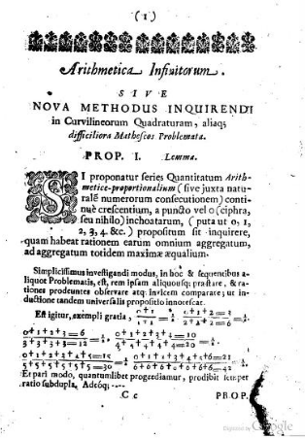

*Arithmetica* *Infinitorum*, Proposition 1, Page 1

**Task 1**. Translate each numerical expression written to modern day notation.Note: + , =, long divide signs mean the same as today.

**Task 2**. Write the next ratio in the pattern. Does it have the same result as the prior ratios?

**Task 3.** Wallis assumed that the pattern holds by “induction” principle. His argument was an argument of “precedents and patterns” [3, Stedall, page 3]. He assumes that a pattern, once established, will continue to hold indefinitely. What do you think of this style of argument? Do you consider it valid or invalid?

In Proposition 2, Wallis developed the formula for the sum of the integers from 0 to *l*. I use *l* because he used it, although we would now use *n*.

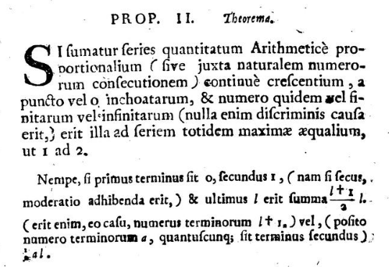

*Arithmetica* *Infinitorum*, Proposition 2, page 3

Literal Translation of second paragraph: If the first term is 0, second 1, (if it is not, the adjustment will be used) and end in *l*, the sum is ; (for the case where the number of terms is *l +*1.) or (assuming the number of terms is *a*, whatever the second term) .[2]

Modern Translation: If the first term of the sum is 0, the second term is 1, and we continue adding the next consecutive numbers, ending in *l,* then the sum is , or, if we let the number of terms be *a*, the sum is .

In modern algebraic notation, we would write: 

In proposition 3, Wallis seemed to suddenly present a new problem, but if we pay close attention, we can see how he used algebra and arithmetic progression to solve this geometry problem.

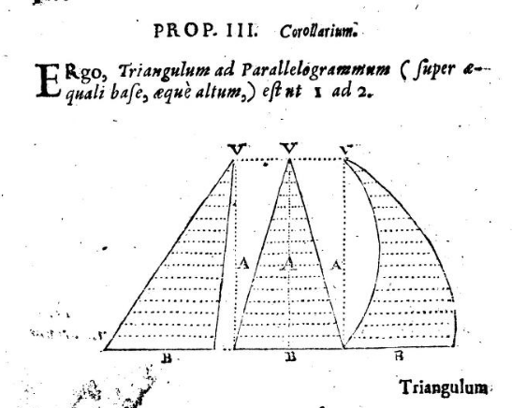

*Arithmetica* *Infinitorum*, Proposition 3, page 2

Literal Translation: Therefore, triangle to parallelogram (on equal base, equal altitude), is as 1 to 2.

Modern Translation: Therefore, the ratio of the area of a triangle to the area of a parallelogram (with equal bases of length B and equal heights of length A) is 1 to 2.

The proposition continued:

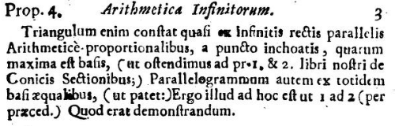

*Arithmetica* *Infinitorum*, Proposition 3, page 3

[3]He wanted to prove that if we take the base of the triangle, extend it up through the altitude to create a parallelogram of equal width as the base, then the triangle’s area is half the parallelogram’s area.

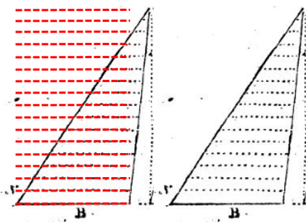

Figure 1 from Proposition 3, with parallelogram overlay

The method of indivisibles is a ratio created by filling up the desired shape with chords of length *x*, then dividing the sum of the chords by the largest of the chords. Moreover, Wallis claims that no matter how many chords we use to fill the shape, the ratio remains intact, 1 to 2.

Let’s say that the triangle in Figure 1 has chord length 16 for its base, then we would use 15 more chords of decreasing length to fill the triangle’s area and the surrounding parallelogram would have a chord length 16 at the same intervals to fill its area. The Wallis ratio is



**Task 4.** Evaluate the above ratio.

**Task 5.** Write the nth case for the ratio, simplify it. Does it validate Wallis’s argument?

**Task 6.** Rephrase this problem as a definite integral. What do the function and the limits of integration have to be in order for the area of the triangle to be ½?

## Addressing Error in the Sums

Wallis continues to use this ratio or method of indivisibles to determine the area of the semi-parabola in proportion to a parallelogram with the same base. Once the figure curves, Wallis discovers an error. Being good at pattern, he able to set up the desired ratio and discusses the decreasing error as the ratios are increased by a larger number of chords.

Since the parabola is x2, the sum in the numerator is the sum of square numbers, starting at 0, and the denominator is the sum of the greatest. Similar to propositions 1-3, Wallis proposes in proposition 19 and 21 the sequences of series; increasing each sequence by a square number.

**Proposition 19:** Examine the ratio of a series of square numbers, starting at 0, over the same sum of the greatest:

Literal Translation:

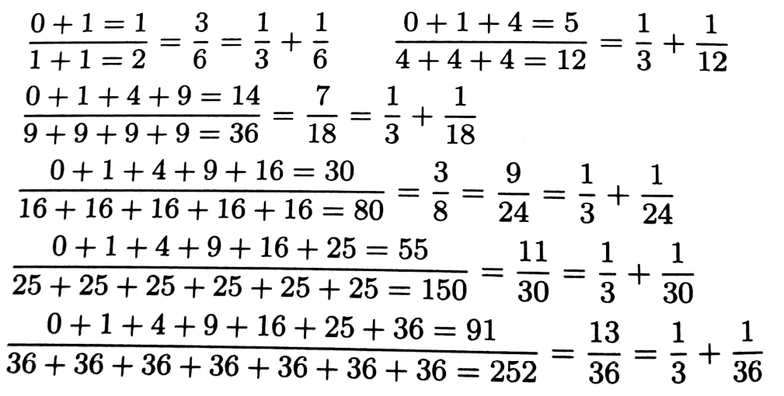

Since, moreover, as the number of terms increases, that excess over one third is continually decreased, in such a way that at length it becomes less than any assignable quantity (as is clear); if one continues to infinity, it will vanish completely.

*Arithmetica* *Infinitorum*, Proposition 19 [2, Stedall]

**Task 7.** **(a)** Proposition 20: Examine the sum and the nature of the excess over the proposed ratio of 1/3. What is the pattern of the excess with respect to 6?

**(b)** Create a formula for the nth proportion and the nth excess.

## The Proportion for a Half Parabola to a Parallelogram

## Proposition 23 (Literal Translation)

In the same way, the complement of a half parabola (understood as figure AOT, which with the half parabola itself completes a parallelogram) is, to the parallelogram TD (on the same or equal base of of equal height), as 1 to 3. (And consequently the half parabola itself is to the same parallelogram as 2 to 3)

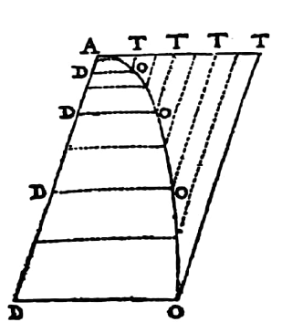

For in the figure AOT, let the vertex be A, the diameter AT, the base TO, and as many parallels to it as you wish (between base and vertex) TO, TO, etc. Since (by Proposition 21 of *On Conic Sections*) the straight lines DO, DO, etc are as the square roots of the lines AD, AD, etc., conversely AD, AD, etc., that is, TO, TO, etc., will be as the squares of the same DO, DO, etc., that is of AT, AT, etc. Therefore the whole figure AOT (consisting of an infinite number of straight lines TO, TO, etc., the squares of the arithmetic proportionals AT, AT, etc) will be, to the parallelogram of equal height TD (consisting of the same number of straight lines equal to the greatest TO itself, as 1 to 3, by Proposition 21. (Which was to be proved.) And consequently, the half parabola AOD (the remainder of the parallelogram) will be to the same parallelogram as 2 to 3.

*Arithmetica* *Infinitorum*, Proposition 23 [2, Stedall]

**Task 8. (a)** What two areas are being found and what does Wallis claim to be their areas?

**(b)** What are their functions?

**(c)** What does the area of the parallelogram have to be for Wallis’s proportions to be correct?

**Task 9. (a)** Label the given graph on the worksheet.

**(b)** What part is the half-parabola and what part is the complement?

**(c)** Explain the parallel lines DO, AT, and TO. Why can we have as many as we want?

**Task 10.** Draw the equivalent graph(s) onto a modern day Cartesian coordinate system. Label the graph appropriately.

**Task 11.** Discuss Wallis’s argument, then rework the two areas, using a definite integral. Determine the limits of integration.

**Task 12. (a)** What method would you speculate that Wallis will do for the cubic parabola, that is, x3. Confirm by examining Proposition 39.

(b) Create a formula for the sum of *n* cubes.

(c) Create the nth formulas for the ratio of cubic chords divided by the greatest chord and its excess.

# Works Cited

[1] Ball, W. W. Rouse. Short Account of the History of Mathematics, 4th Edition, 1908, <https://www.maths.tcd.ie/pub/HistMath/People/Wallis/RouseBall/RB_Wallis.html>

[2] Stedall, Jacqueline. *Arithmetica* *Infinitorum* - English Translation, Springer, 2004

[3] Stedall, Jacqueline. The Discovery of Wonders: Reading between the Lines of John Wallis’s Arithmetica Infinitorum, *Archive for the History of Exact Sciences* Vol 56. No 1 (November 2001), pp. 1-28, Springer

[4] Wallis, John. *Arithmetica Infinitorum,* 1656 (Scanned digital copy of 2nd edition in Google Books)

[5] MacTutor History of Mathematics. <http://www-history.mcs.st-and.ac.uk/Biographies/Wallis.html>, 2002

**Endnotes**

1. Method of Indivisibles: A geometrical object is considered to be made of geometric objects of dimension one lower (e.g., square made up of line segments, or chords).

   Method of Infinitesimals: A geometrical object is considered to be made of infinitely small geometric objects of the same dimension.
2. There is an ink blotch on the copy at the end of the proposition. I assume 2 in the denominator in order to be consistent.
3. Literal Translation : For the triangle consists, as it were, of an infinite number of parallel lines in arithmetic progression, starting from a point, of which the longest is the base (as demonstrated in Pr. 1 & 2 of our book *Conics Sectionibus*;) Parallelograms consists of the same number of lines equal to the base (as is clear). Threfore, the former to the latter is as 1 to 2 (from what has gone before). Quod erat demonstradum.